Smartphone Usage Analysis

1. General Usage: What is the average daily_phone_hours across the entire dataset?
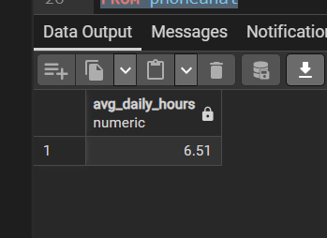
2. Demographics: What is the gender distribution among the surveyed users?
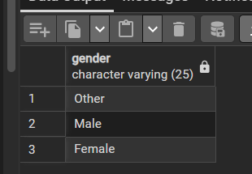
3. App Engagement: Which occupation has the highest mean app_usage_count?
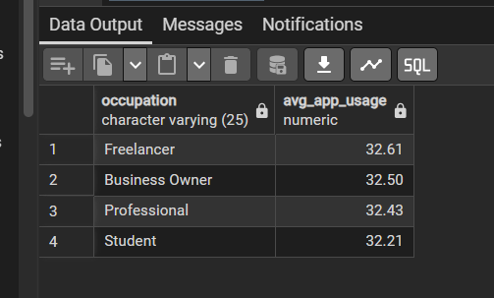

4. Device Preference: How many users are on iOS vs. Android (based on device_type)?
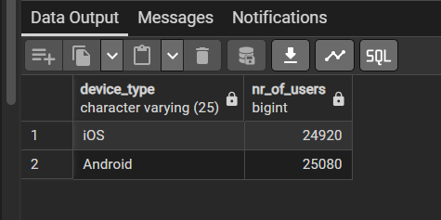

5. Health Baseline: What is the average number of sleep_hours for the total population?
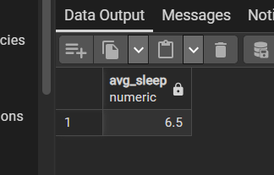

6. Productivity Range: What are the minimum and maximum values for the work_productivity_score?
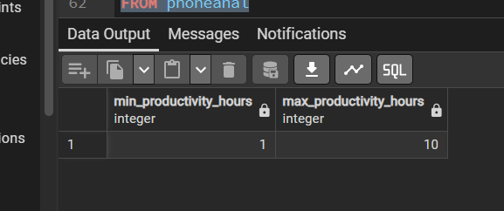

7. Caffeine Habits: What is the most common number of caffeine_intake_cups reported?
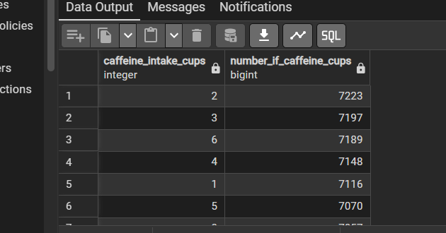

8. Weekend vs. Weekday: What is the average weekend_screen_time_hours compared to the daily average?
9. Stress Check: How many users report a stress_level above 7 (on a scale of 1-10)?
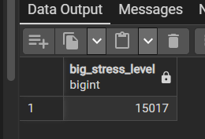

10. Age Groups: What is the average age of the users in this dataset?
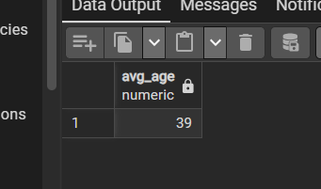

11. Social Media & Stress: Is there a positive correlation between social_media_hours and stress_level?
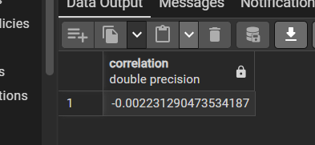

12. The "Sleep Debt": Do users who spend more than 5 hours on social media sleep significantly less than those who spend less than 2 hours?
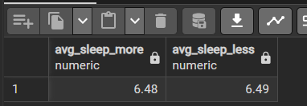

13. Productivity Impact: Is there a visible drop in work_productivity_score as daily_phone_hours increases?
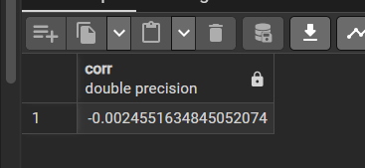

14. Caffeine & Sleep: How do sleep_hours fluctuate across different levels of caffeine_intake_cups?
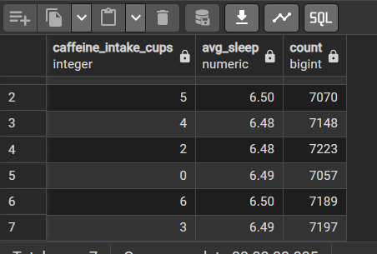
15. Screen Time Ratio: What percentage of total daily_phone_hours is dedicated specifically to social_media_hours for each occupation?
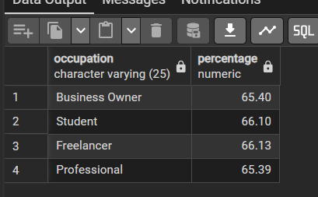

16. Generation Gap: Compare the app_usage_count between users under 25 and users over 45.
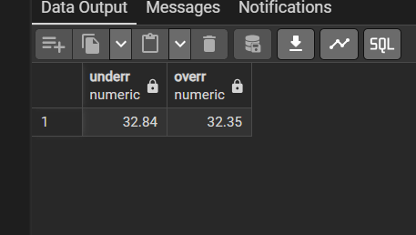
17. Weekend Surge: Which occupation shows the highest increase in screen time during the weekend compared to weekdays?
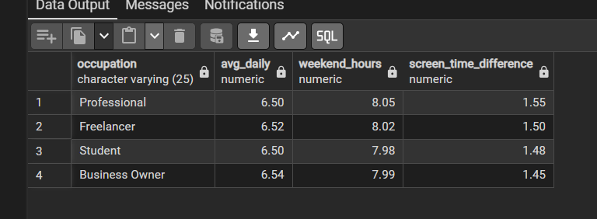

18. Stress by Device: Does stress_level vary significantly between different device_type users?
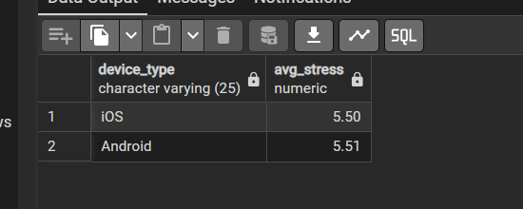

19. The "Doomscrolling" Indicator: Is a high app_usage_count more closely linked to stress_level or social_media_hours?
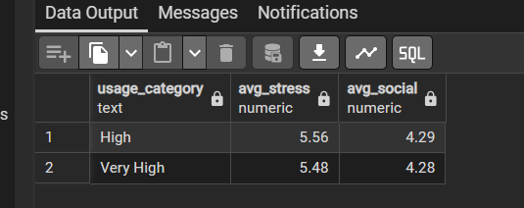
20. Productivity & Sleep: Identify the "Sweet Spot"—what number of sleep_hours is associated with the highest average work_productivity_score?
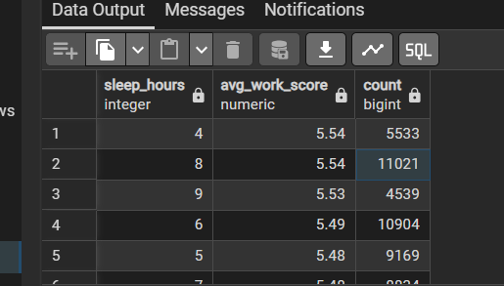

21. The Efficiency Paradox: Identify users who have high daily_phone_hours but still maintain a high work_productivity_score. What are their common characteristics (age, occupation, sleep)?
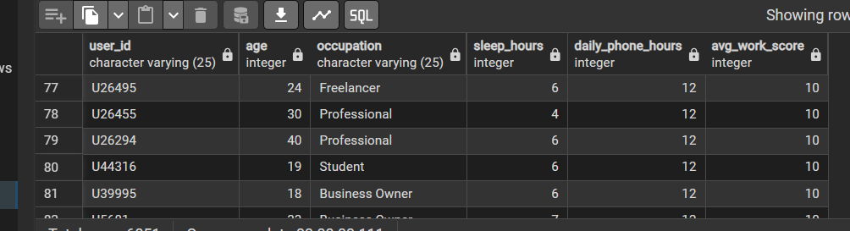

22. User Segmentation: If you were to cluster users into three personas—"Digital Nomads," "Stressed Power Users," and "Balanced Users"—what would the boundaries for each group be?
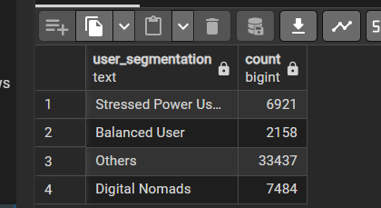

23. Outlier Detection: Find users whose weekend_screen_time_hours is more than 3 standard deviations away from the mean. Are these mostly students or professionals?
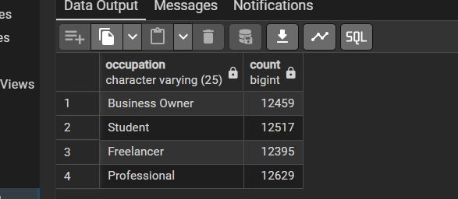

24. Caffeine Compensation: Perform a group-by analysis to see if users with high stress_level and low sleep_hours have a higher-than-average caffeine_intake_cups.
Predictive Modeling Prep: Which variable (Social Media, Sleep, or Caffeine) is the strongest predictor of stress_level based on a correlation matrix?
App Intensity: Calculate a new metric: Minutes_Per_App_Open (Total hours * 60 / App usage count). Which occupation has the shortest, most frequent sessions?
The "Burnout" Risk Score: Create a weighted formula for a "Burnout Risk Score" using stress_level, sleep_hours (inverted), and daily_phone_hours. Who ranks in the top 5%?
Demographic Deep Dive: Within the highest stress category, what is the most prevalent occupation and age range?
Non-Linear Trends: Does work_productivity_score peak at a certain level of caffeine_intake_cups and then decline? (The "Inverted-U" theory).
Data Integrity: Identify any "impossible" users (e.g., those whose daily_phone_hours + sleep_hours + work_hours (est) exceed 24 hours).

